**Guinea-Bissau country profile**

Published

2 March

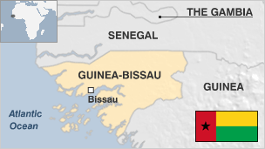

**West Africa's Guinea-Bissau was part of the Portuguese Empire for centuries.**

Once hailed as a potential model for African development, the country is now one of the poorest in the world.

The vital cashew nut crop provides a modest living for most of Guinea-Bissau's farmers, and is the main source of foreign exchange.

But today the nation has a massive foreign debt and an economy that relies heavily on foreign aid. It has become transhipment point for Latin American drugs.

At the end of the 1990s the country experienced a conflict which drew in Guinea, Nigeria, Senegal, and France and ended with the president going into exile.

* Read [more country profiles](http://news.bbc.co.uk/1/hi/country_profiles/) - Profiles by [BBC Monitoring](http://www.bbc.co.uk/monitoring)

**President: Umaro Sissoco Embaló**

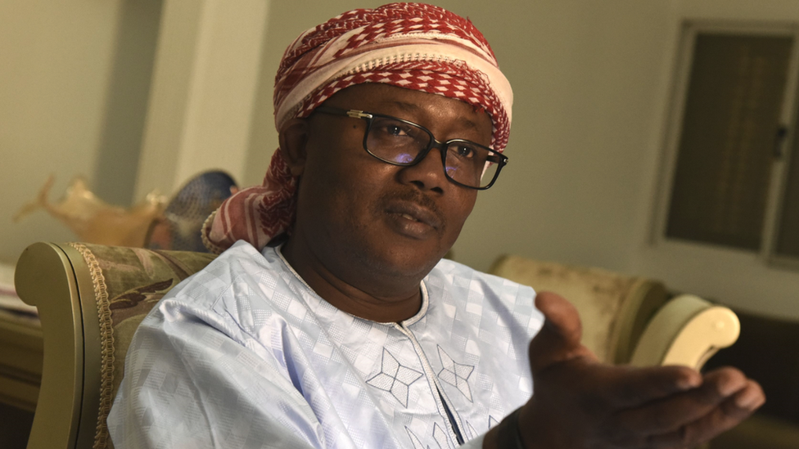image copyrightSEYLLOU/AFP/Getty Images

Mr Embaló won the December 2019 presidential election, but faced a last-minute stand-off with parliament before taking office in February.

This reflected the continuing instability of state institutions in a country that has seen nine coups or attempted coups since 1980, and the resistance of the long-governing PAIGC party to the victory of an opposition candidate.A former prime minister, Mr Embaló is the first president to be elected without the backing of the PAIGC.

His predecessor, Jose Mario Vaz, was the first elected leader since the army mutinied in 2012 and plunged the country - already plagued by corruption and cocaine trafficking - into chaos, and the first to complete his term without being overthrown.

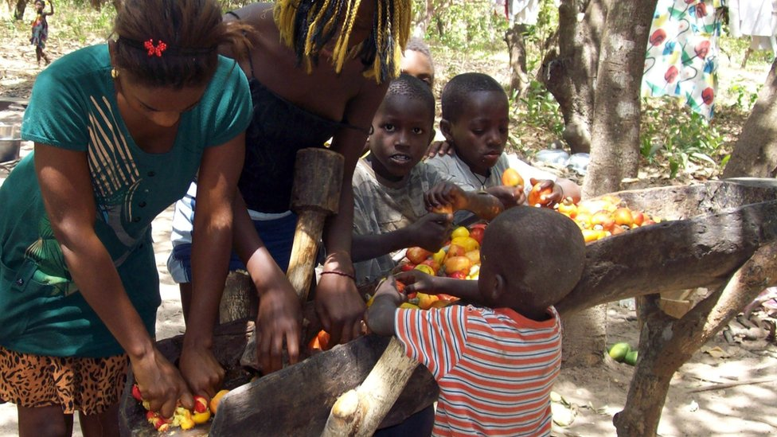image copyrightGetty Images

image captionGuinea-Bissau is one of the world's biggest producers of cashew nuts

The constitution provides for press freedom and there is some media diversity, says US NGO Freedom House. But it says journalists face harassment.

Private radio stations operate alongside the state broadcaster. A government newspaper publishes alongside non-state titles.

# Guinea-Bissau profile - Timeline

Published

19 February 2018

## A chronology of key events:

**Pre-15th century** - The area of what is now Guinea-Bissau comes under the influence of the Mali Empire and becomes a tributary kingdom known as Gabu.

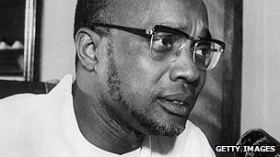image copyrightGetty Images

image captionAmilcar Cabral fought for independence but was assassinated before Guinea-Bissau became a sovereign state

**1446-47** - First Portuguese arrive; subsequently administered as part of the Portuguese Cape Verde Islands, the Guinea area becomes important in the slave-trade.

**1879** - Guinea-Bissau becomes a separate colony. Portuguese control of the interior is slow and sometimes violent, and not effectively achieved until 1915.

## War of independence

**1951** - Guinea-Bissau declared a province of Portugal.

**1956** - Amilcar Cabral establishes the African Party for the Independence of Guinea and Cape Verde (PAIGC).

**1963-74** - PAIGC launches war of independence.

**1973** - Amilcar Cabral assassinated. PAIGC unilaterally declares Guinea-Bissau independent of Portugal and gives it its present name.

**1974** - Portugal grants Guinea-Bissau independence with Luis Cabral, Amilcar Cabral's brother, as president.

## Military intervention

**1980** - Luis Cabral ousted in military coup led by Joao Bernardo Vieira; plans for unification with Cape Verde dropped.

**1990** - Parliament revokes the PAIGC's status as the sole legitimate party.

**1994** - Vieira chosen as president in Guinea-Bissau's first free election.

**1998** - Army mutinies after Vieira sacks his army commander, General Ansumane Mane, whom he accused of allowing weapons to be smuggled to rebels in Senegal.

**1999** May - Soldiers led by General Ansumane Mane topple Vieira.

Military junta installs Malam Bacai Sanha, the former speaker of parliament, as interim president.

## Domestic tensions

**2000** January - Kumba Yala elected president.

**2000** November - General Mane killed, allegedly after trying to mount a coup.

**2001** January - Guinea-Bissau Resistance (RGB) party pulls out of ruling coalition saying it wasn't consulted about a cabinet reshuffle.

**2001** May - IMF, World Bank suspend aid over millions missing from development funds. Towards year's end an IMF team praises improvements in financial controls.

**2001** November - Foreign minister Antonieta Rosa Gomes dismissed after criticising President Yala. Increasing concern over the president's erratic behaviour.

## Yala deposed

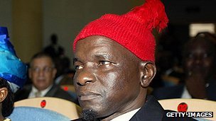image copyrightGetty Images

image captionKumba Yala is known for his trademark woolen hat

**2001** December - Government says it has thwarted a coup attempt by army officers. Opposition casts doubt on allegations. Prime Minister Faustino Imbali is sacked for "failing to meet expectations".

**2002** November - President Yala says he plans to dissolve parliament and call early elections. The move comes amid a long-running row with his prime minister.

**2003** September - Military coup ousts President Yala. Civilian administration headed by interim President Henrique Rosa and interim Prime Minister Antonio Artur Rosa is sworn in after military and political parties agree to hold parliamentary and presidential elections.

**2004** March - The former ruling PAIGC wins general election.

**2004** October - Mutinous soldiers kill the head of the armed forces in pursuit of demands which include payment of outstanding wages.

## Vieira returns

**2005** April - Joao Bernardo Vieira, former president toppled in 1999 rebellion, returns from exile in Portugal.

**2005** May - Former President Kumba Yala, who was deposed in 2003, declares that he is still the rightful head of state. He stages a brief occupation of the presidency building.

**2005** July - Former military ruler Joao Bernardo Vieira wins a run-off vote in presidential elections.

**2006** March-April - Guinea-Bissau soldiers battle Senegalese rebels along the southern border.

**2006** October - Guinea-Bissau appeals for international help to stop people-traffickers using its remote coastline to smuggle migrants, including Asians, to Europe.

**2007** March-April - Prime Minister Aristides Gomes resigns after his government loses a no-confidence vote. Martinho Ndafa Kabi is appointed as consensus prime minister.

**2007** June - Donors have one last opportunity to save Guinea-Bissau from chaos and to combat Latin American drug cartels, the UN and International Monetary Fund warn.

**2007** December - Parliament passes law guaranteeing amnesty for any violence committed during the years of political unrest between 1980 and 2004.

**2008** August - President Vieira dissolves parliament.

**2008** November - President Vieira survives a gun attack on his home by mutinous soldiers, in what appears to be a failed coup.

## Vieira assassinated

**2009** March - President Joao Bernardo Vieira is shot dead by renegade soldiers, hours after a bomb attack that killed the army's chief of staff, General Tagme Na Waie.

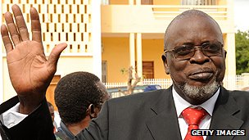image copyrightGetty Images

image captionPresident Malam Bacai Sanha died in office

**2009** July - Malam Bacai Sanha wins presidential election in a run-off.

**2010** April - Mutinous soldiers briefly detain Prime Minister Carlos Gomes Junior and replace armed forces chief.

US names two top military officials as international drugs traffickers and freezes their US assets.

**2010** June - Leader of April's mutiny, General Antonio Indjai, is made army chief.

**2010** August - EU announces it is ending mission to reform Guinea Bissau's security forces, saying lack of respect for rule of law is making this an impossible task.

**2010** October - US expresses concern over Guinea Bissau government's decision to reinstate alleged drugs kingpin Jose Americo Bubo Na Tchuto as head of navy. Mr Na Tchuto is a close ally of army chief General Antonio Indjai.

**2010** December - Former army chief Jose Zamora Induta, who was arrested during April mutiny, is released from prison but days later placed under house arrest.

**2011** February - EU suspends part of its aid to Guinea-Bissau because of concerns over governance and the rule of law.

**2011** July-August - Thousands take to the streets to demand the resignation of Prime Minister Carlos Gomes Junior for his failure to curb rising food prices.

## Instability

**2011** December - Prime Minister Carlos Gomes Junior says the authorities have foiled a coup attempt against President Malam Bacai Sanha, mounted while the he was receiving medical treatment. Navy chief Jose Americo Bubo Na Tchuto is accused of masterminding the coup and arrested.

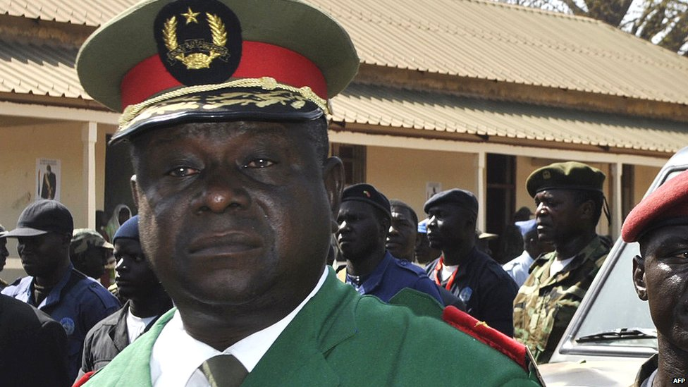image copyrightAFP

image captionEx-armed forces chief Antonio Indjai, who led a coup in 2012 and was sacked two years later, is suspected by the US of drug smuggling

**2012** January **-** President Malam Bacai Sanha dies in hospital in Paris. National Assembly head Raimundo Pereira becomes interim president.

**2012** April-May - Soldiers topple the government. Interim President Pereira and leading presidential contender and ex-PM Carlos Gomes Junior, are arrested. A transitional government led by Manuel Serifo Nhamadjo is formed. UN imposes travel bans on the coup leaders and key supporters.

**2012** July - The UN Security Council expresses concern that drug trafficking has increased since the coup, and demands a return to constitutional rule.

**2012** October - Seven killed in raid on an army barracks, which the transitional government describes as a failed coup attempt.

**2013** April - US operatives arrest ex-navy chief Jose Americo Bubo Na Tchuto and charge him with drug trafficking.

**2013** December - Row with Portugal over refugees from Syria, who allegedly arrived by plane from Guinea-Bissau with false documents. Guinea-Bissau's foreign minister quits, Portuguese airline TAP suspends air link.

**2014** May - Presidential election run-off is won by Jose Mario Vaz.

**2014** September - President Jose Mario Vaz sacks the powerful armed forces chief, Antonio Indjai, whom the US accuses of plotting to traffic cocaine and sell weapons to Colombian rebels.

**2015** May - International donors pledge more than $1.1bn to help Guinea-Bissau's economy revive after years of instability.

**2015-2019** - President Jose Mario Vaz sparks a political crisis by sacking a series of prime ministers in a power struggle with his opponents in the ruling PAIGC.

**2020** February - Former prime minister Umaro Sissoco Embaló takes office after winning the presidential election, ending 46 years of PAIGC or military rule.